How Program Contacts Management (PCM) works

Only certain DOT&E staff members have permissions to add or delete items from DCAPX or to add or remove users from SharePoint groups. We have, however, provided a method for OTA points of contact to perform the following administrative tasks:

* Add associates who may be able to view OTA content or submit CONOPS.
* Implicitly add or remove associates to or from OTA SharePoint groups.

We do this with a set of server-side solution objects that collectively are the **Program Contacts Management (PCM)** function.

# User requests access to DCAPX

New users must either be known to DOT&E (and added by an administrator to the DCAPXOTA group), or they must request access by emailing [osd.pentagon.dote.list.cap@mail.smil.mil](mailto:osd.pentagon.dote.list.cap@mail.smil.mil).

# Administrator First Adds User to DCAPXOTA

Administrators (DCAPXOwners) must first add OTAs to the DCAPXOTA SharePoint group. Only administrators manage members of this group.

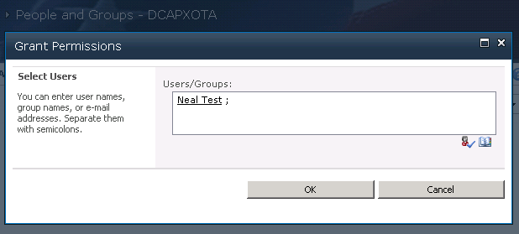

# Administrator then Adds User to ProgramContacts list

An admin then adds a primary POC for an OTA by clicking the Program Contacts link in the left menu.



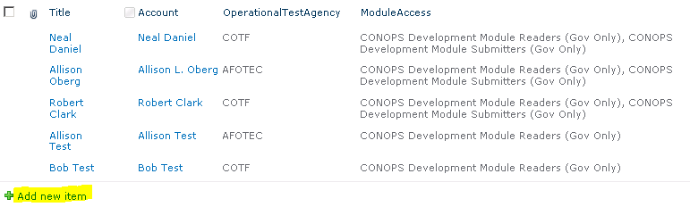

Clicking Add new item brings up the form for adding items to a list.

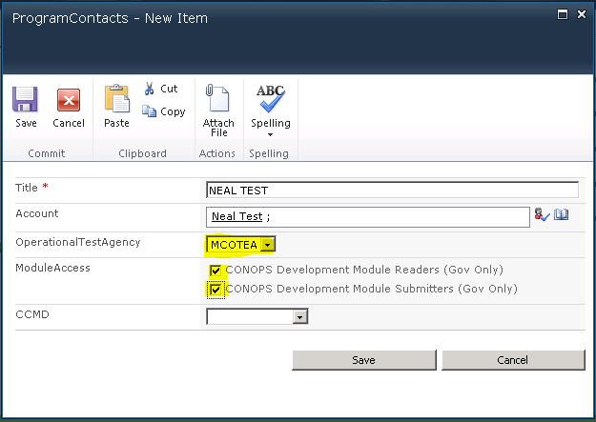

The admin sets the user’s OperationalTestAgency and ModuleAccess to include submission of CONOPS.

# Administrator Confirms Group Membership

From Site Actions / Site Permissions (/layouts/user.aspx), the admin may then confirm the user’s group membership by clicking the Chick Permissions icon from the Ribbon.

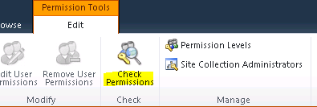

The new user should be a member of DCAPXOTA, CONOPSDevReaders[OTA], and CONOPSDevSubmitters[OTA], and probably the Style Resource Readers group.

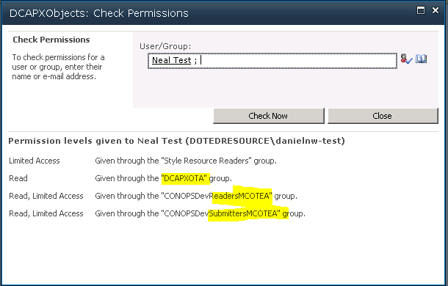

Now that we have a primary point of contact for the OTA (MCOTEA in the above example), we can let the POC add or remove associates from those available in the DCAPXOTA group. An administrator must always add or remove users from the DCAPXOTA group, but after that, the POC should keep the POC list up-to-date by adding or removing associates and keeping their ModuleAccess updated.

# PCM User Interface for non-admins

The point of contact for an OTA may manage associates by clicking on Program Contacts in the left menu.



For non-admins, this link opens a custom view of items from the Program Contacts list filtered by the user’s OTA.

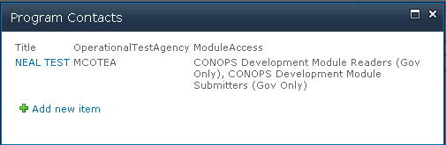

Clicking Add new item opens a form where the user may add an associate.

If the user is not a member of the DCAPXOTA group, a validation will fail.

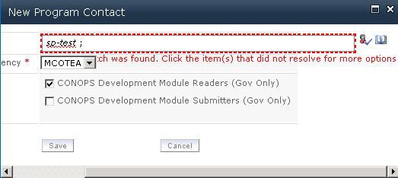

The OTA may request the user be granted access to DCAPX.

The administrator will then add the user to the DCAPXOTA group.

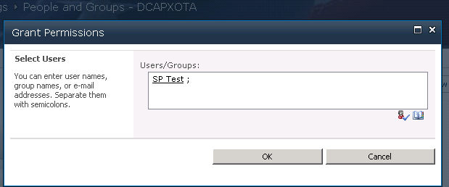

Then the New Program Contact form validation will be successful when the OTA POC attempts to add an associate.

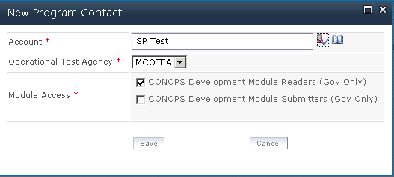

An admin may verify that the user is listed in the ProgramContacts list.

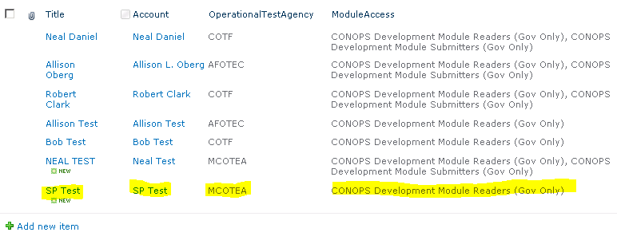

A check of the new user’s permissions should show group membership for DCAPXOTA and any other groups related to the ModuleAccess assigned.

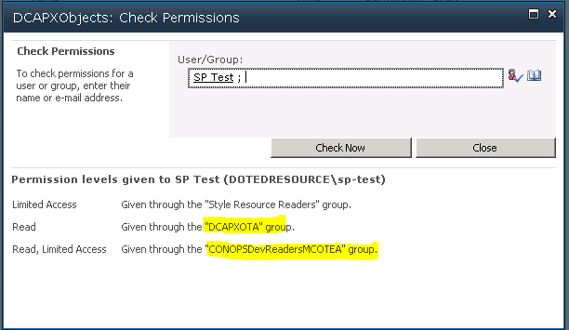

DCAPX for Associate OTA

For the associate OTA the user will see content for their OTA (MCOTEA in this example).

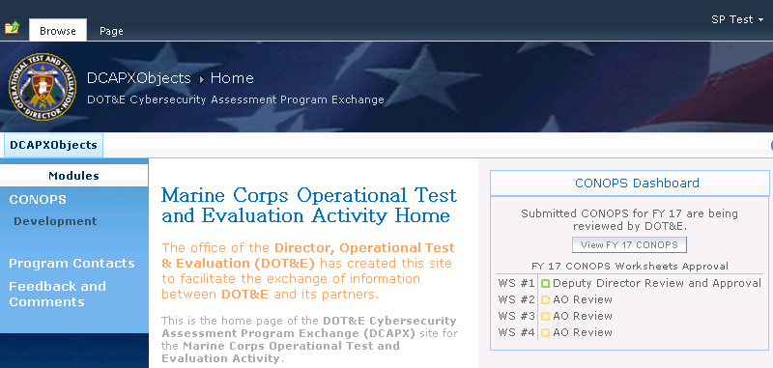

This includes the CONOPS Dashboard.

The user may also view CONOPS worksheets from the CONOPS Development Module.

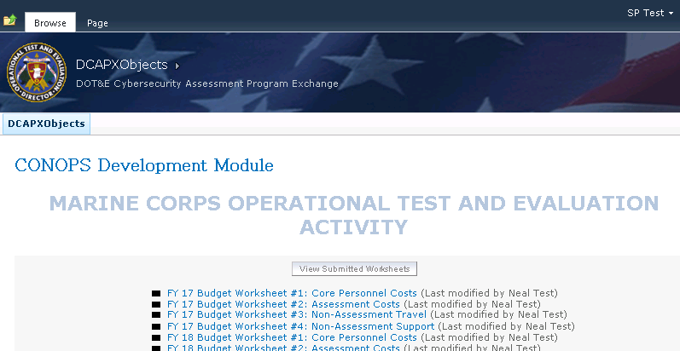

But the user may not make edits to worksheets or submit them unless their ModuleAccess includes the submitter option.

# How it works

In Visual Studio’s Solution Explorer you will find most of the code for PCM under Layouts/DCAPXSolution/ProgramContacts, and an Event Receiver under EventReceivers/ProgramContactsEventReceiver.

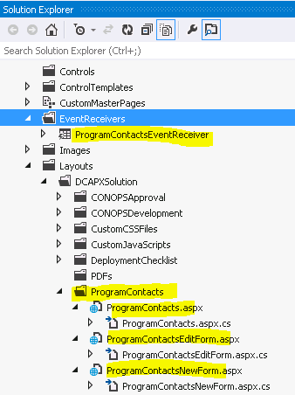

The ProgramContactsNewForm and ProgramContactsEditForm contain methods to allow the OTA POC to add or edit an item for an associate as long as the user is a member of DCAPXOTA and not already in the ProgramContacts list.

The ProgramContacts page presents a view of the ProgramContacts list with a delete graphic next to items the POC is to manage. The form prevents them from deleting themselves.

We elevate privileges for these operations to ensure we do not have to grant the user Contributor permissions on the site when we really just want the user to be able to contribute to certain lists and libraries at certain times.

JavaScript in Layouts/DCAPXSolution/CustomJavaScripts/ProgramContactsForm.js contain form validation.

CSS in Layouts/DCAPXSolution/CustomCSSFiles/ProgramContacts.css contain button styles.

The list event receiver includes methods that update group memberships based on ModuleAccess selections.